**Behaviour of incubating parent prior to return of its partner**

In 14% of exchange observations the incubating parent left before its partner was present around the nest (23 cases out of 164). However, only in ten cases the parent left the nest more than 1 min prior to partner’s return (median = 4.6 min, range: 2.6 min – 3.9 h) and in only three cases more than 10 min prior to partner’s return. This suggests, together with the scoring of the off-nest partner’s presence, that in most of the observed cases the off-nest partner likely returned prior to departure of the incubating parent.

The calling rate of the incubating parent prior to exchange (i.e. prior to the return of the off-nest parent) was double the calling rate during regular incubation (Figure 1a, Supplementary Table 2a,b), whereas the probability of fly-off was similar in observations prior to exchange and in those during regular incubation (Figure 1b, Supplementary Table 2c,d). Both, the calling rate and fly-off probability were similar across sexes and incubation period (Supplementary Table 2b, d).

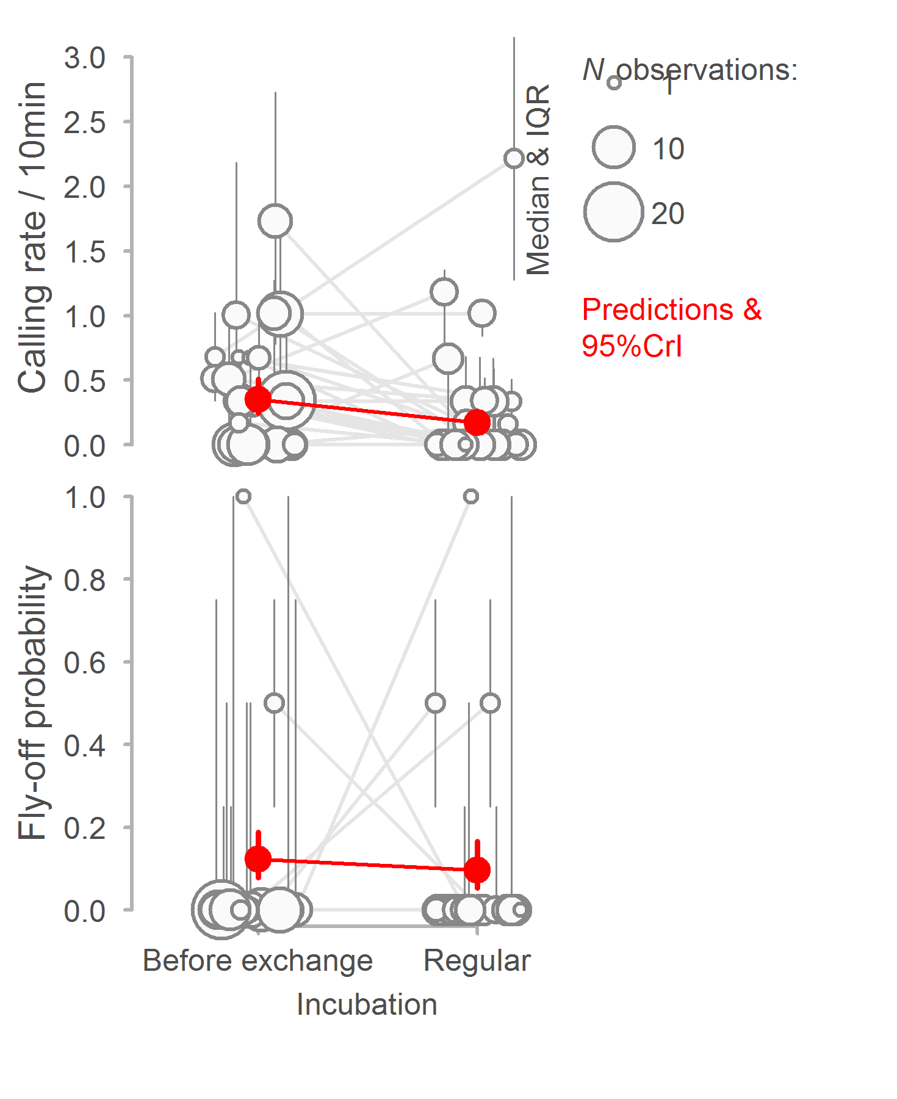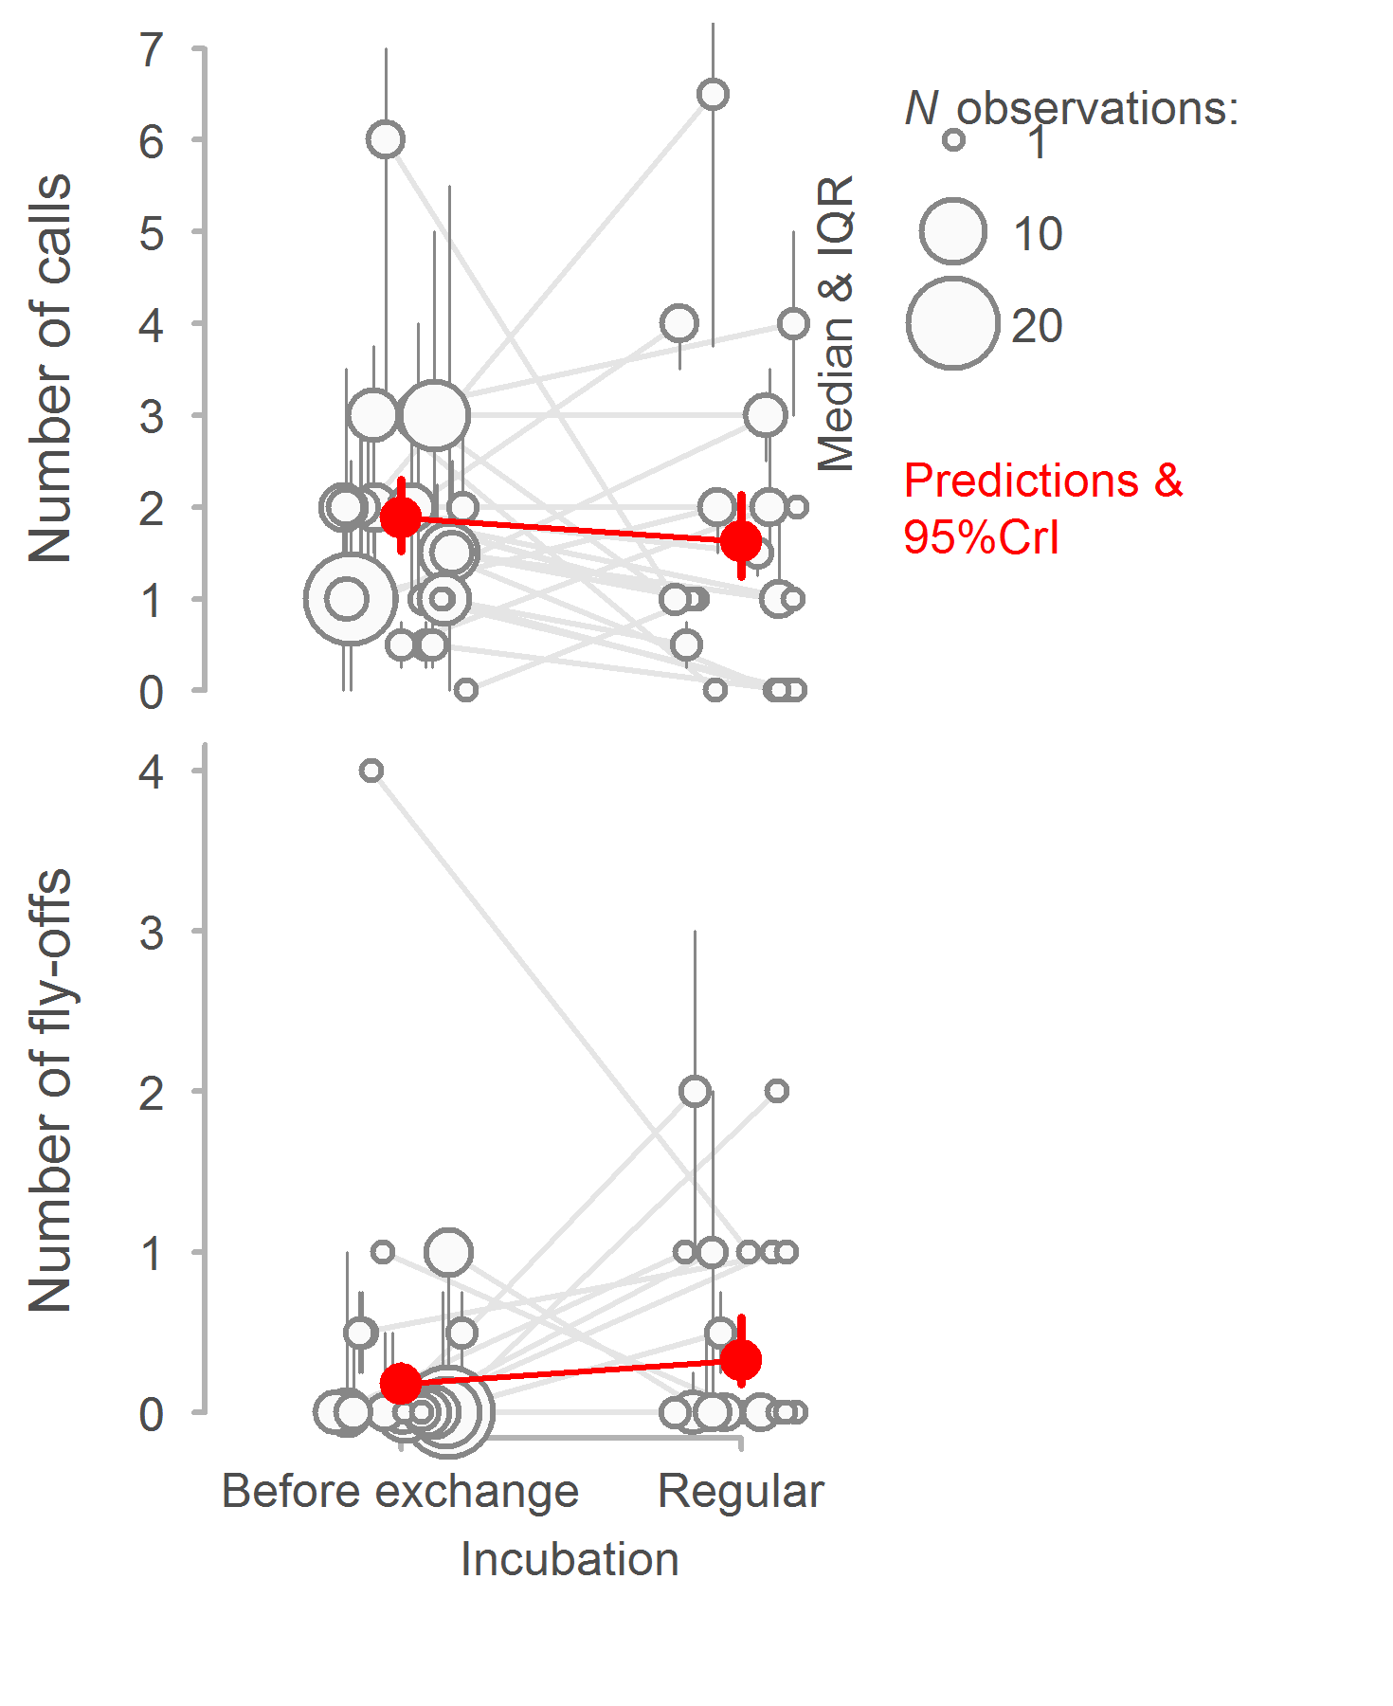

**Figure 1 | Calling rate and fly-off probability of incubating bird prior to exchange and during regular incubation.** Circles with bars indicate median and interquartile range (IQR) for each nest. Grey lines connect observations from the same nest. Red points with bars indicate model predictions with 95%CI (Supplementary Tables 1a, c) based on the joint posterior distribution of 5,000 simulated values generated by the ‘sim’ function in R40.

The incubating parents called more as the exchange neared (Figure 2a) - calling occurred on average at 0.3 of observation time (CI: 0.23 – 0.378, n = 261 calling cases from 28 nests; 0 represents the return of the partner, i.e. start of exchange, 1 the time the observations started; random intercept nest ID explained 25% of the variance, i.e. repeatability was 25%). On the other hand, calling parents flew-off the nest less as the exchange neared (Figure 2b) – fly-offs occurred on average at 0.64 of observation time (CI: 0.53 – 0.73, n = 25 fly-off cases from 15 nests; nest ID explained no variance). Note that our video data provide only for a rough estimation of time the off-duty parent was present; thus, we cannot exclude the possibility that these results (Figure 2) are driven by off-duty partner being actually present.

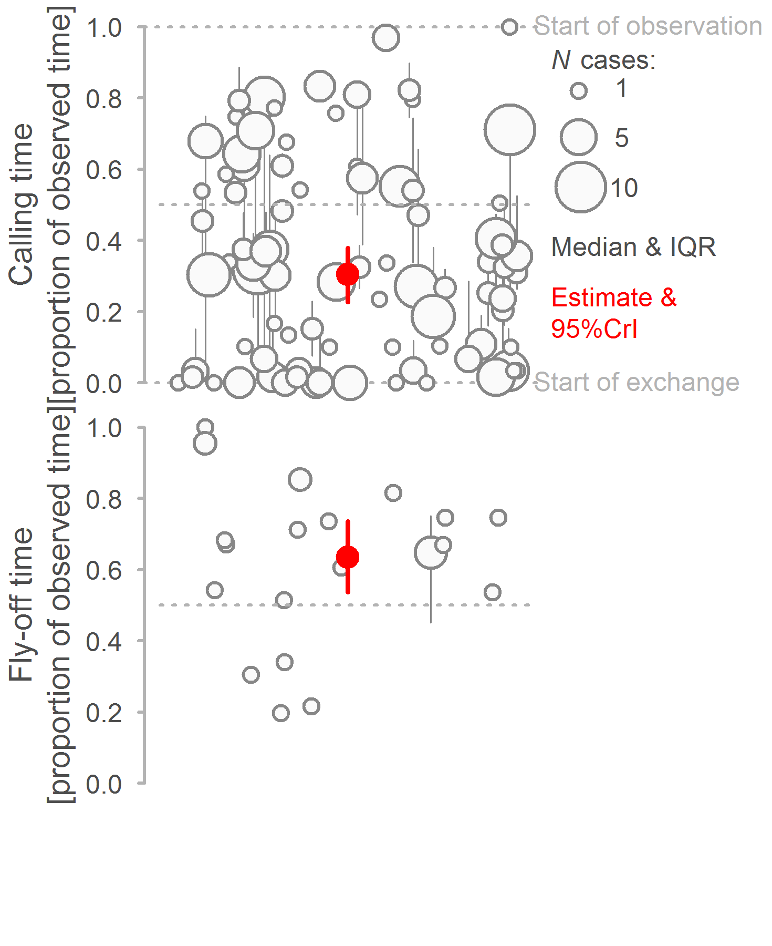

**Figure 2 | Time of calling rate and fly-off within before exchange observation session.** Circles with bars indicate median and interquartile range (IQR) for each observation session. Red points with bars indicate model estimates with 95%CI (Supplementary Tables 1a, c) based on the joint posterior distribution of 5,000 simulated values generated by the ‘sim’ function in R40. *N*calling= 261 calling instances from 89 before exchange observation sessions of 28 nests. *N*fly-off= 25 fly-offs from 20 before exchange observation sessions of 15 nests.

**Exchange procedure**

*Duration* – We have detected the off-duty parent on the video (by sight or sound) 0 min before it arrived to the close vicinity of the nest, that is 0 min before it initiated the exchange (median, min = 0 s, max = 19 min, n = 161 exchanges from 31 nests). The off-duty parent initiated the exchange 24 s before it sat down on the nest (median, min = 5 s, max = 9 min, n = 161 exchanges from 31 nests) and sat down on the nest quicker when it has arrived to the empty nest (i.e. incubating partner has left before off-duty parent arrived) then when incubating partner left after the off-duty bird arrived – be it before or after the off-duty parent initiated the exchange (Figure 3, Supplementary Table 3). The exchange gap, that is time between the incubating parent leaving and off-duty parent sitting down on the nest, lasted 15s (median, min = 0 s, max = 4 h, n = 162 exchanges from 31 nests).

Time span for which the off-duty parent was around the nest before initiating the exchange, time span between initiating the exchange and sitting down on the nest, as well as the exchange gap was similar between sexes and over incubation period (Supplementary Table 3).

*Calling* – While arriving to the vicinity of the nest the off-duty parent called in 30% of exchanges (in 39 out of 131 exchanges where incubating parent left only after the returning one was present); males tended to call more often (24 out of 68 exchanges) than females (15 out of 63 exchanges; for mixed effect model results see Supplementary Table 4a). The incubating parent replied to the call of its returning partner in 36% of exchanges, which was similar between the sexes (Supplementary Table 4b).

The returning parent called most during period when its partner was still on the nest, less after its partner left, and least after it sat down on the nest (Figure 3). While incubating parent still on the nest (i.e., both parents around), the calling intensity of the returning parent (a) tended to correlated with the calling intensity of the incubating parent, but only in exchanges where female was incubating (Figure 4a, Supplementary Table 4c). Also, the calling intensity of the returning parent while incubating parent was still on the nest predicted the calling intensity of the returning parent after the incubating partner left the nest (Figure 4b, Table 4d), but not its calling intensity after the exchange (Figure 4c, Supplementary Table 4e). The calling intensities were unrelated to the day in incubation period (Supplementary Table 4) or to the current or next incubation bout (Supplementary Table 5).

Incubating parent left the nest by flying directly off it in 76% exchanges (47 out of 62 exchanges where nest was not protected by enclosure), in 11 cases it walked off and after few steps flew and in 4 cases it walked off. While leaving the nest the incubating parent called only in 27% of the exchanges (28 out of 150 exchanges where calling could be scored); males were twice as more likely to call (25% of males called, n = 75 exchanges) than females (12% of females called n = 75 exchanges; for mixed effect model results see Supplementary Table xx).

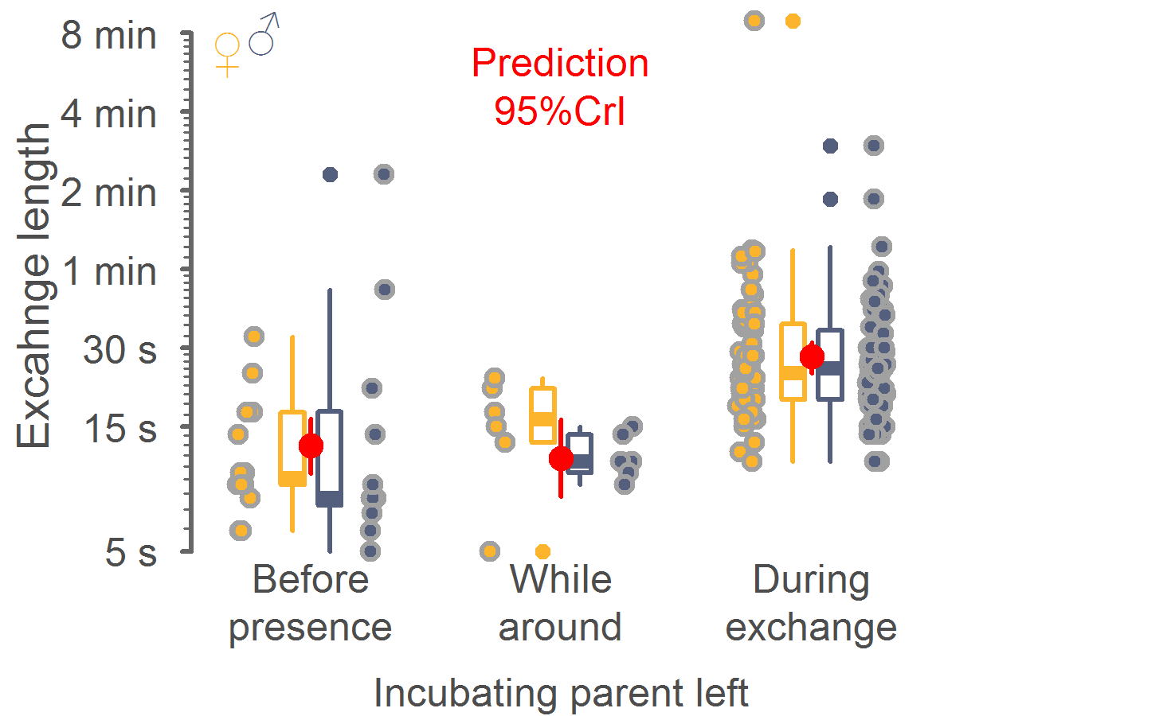

**Figure 2 | Length of exchange in relation to when the incubating parent left the nest.** Circles indicate single observations of time span between off-duty parent initiating the exchange and sitting down on the nest. Box plots depict median (horizontal line inside the box), the 25th and 75th percentiles (box), the 25th and 75th percentiles ±1.5 times the interquartile range or the minimum/maximum value, whichever is smaller (bars), and the outliers (dots). Color of circles and box plots indicates sex (female = yellow, male = grey-blue). Red points with bars indicate model predictions with 95%CI (Supplementary Tables 3b) based on the joint posterior distribution of 5,000 simulated values generated by the ‘sim’ function in R40. *N* = 263 observations from 31 nests.

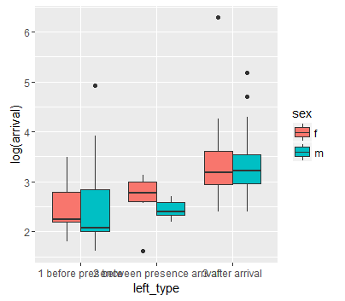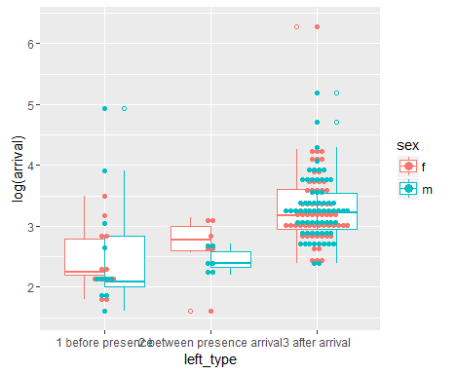

**Callin –**

**When arriving it calls and then**

**When bird leaves the nest it does that and that and usually calls.**

**Supplementary Table 1** | **Calling rate and fly-off probability of incubating bird before exchange and during regular incubation.**

|  |  |  |  |  |  |  |
| --- | --- | --- | --- | --- | --- | --- |
|  |  |  |  |  | 95% CI | |
| Model | Response variable | Effect type | Effect | Estimate | Lower | Upper |
| 1 | Calling rate (10min-1) | Fixed | Intercept (before exchange) | -1.017 | -1.371 | -0.673 |
|  |  |  | Observation (regular incubation) | -0.695 | -0.947 | -0.451 |
| 2 | Calling rate (10min-1) | Fixed | Intercept (before exchange & ♀) | -0.986 | -1.364 | -0.618 |
|  | (Poisson scale) |  | Observation (regular incubation) | -0.676 | -1.029 | -0.322 |
|  |  |  | Sex (♂) | -0.078 | -0.322 | 0.17 |
|  |  |  | Day of incubation | 0.075 | -0.128 | 0.278 |
|  |  |  | Sex × Observation | -0.025 | -0.52 | 0.463 |
|  |  |  | Day of incubation × Observation | 0 | -0.259 | 0.247 |
| 3 | Fly-off (0, 1) | Fixed | Intercept (before exchange) | -1.969 | -2.45 | -1.474 |
|  |  |  | Length of observation (ln(min)) | -0.182 | -0.539 | 0.168 |
|  | (binomial scale) |  | Observation (regular incubation) | -0.262 | -1.031 | 0.503 |
| 4 | Fly-off (0, 1) | Fixed | Intercept (before exchange & ♀) | -2.067 | -2.78 | -1.372 |
|  | (binomial scale) |  | Length of observation (ln(min)) | -0.15 | -0.522 | 0.232 |
|  |  |  | Observation (regular incubation) | -0.519 | -1.816 | 0.751 |
|  |  |  | Sex (♂) | 0.199 | -0.746 | 1.172 |
|  |  |  | Day of incubation | 0.27 | -0.175 | 0.719 |
|  |  |  | Sex × Observation | 0.405 | -1.156 | 2.029 |
|  |  |  | Day of incubation × Observation | -0.08 | -0.816 | 0.645 |

Shown are the posterior estimates (medians) of the effect sizes with the 95% credible intervals (CI) from a posterior distribution of 5,000 simulated values generated by the ‘sim’ function in R (Gelman & Su 2015). Variance components were estimated by the ‘lmer’ function in R (Bates *et al.* 2015).

*N* = 280 observations (162 before exchange, 118 regular incubation) from 32 nests. Continuous predictors were z-transformed (mean-centred and divided by SD). All four models contained nest ID as random intercept. Calling was entered as count and offset specified length of observation in minutes (divided by ten minutes and ln-transformed), which not only controlled for the length of observation, but also generated a calling rate 10min-1.

**Supplementary Table 2** | **Distribution of when incubating parent called or flew-off within before exchange observation.**

|  |  |  |  |  |  |  |
| --- | --- | --- | --- | --- | --- | --- |
|  |  |  |  |  | 95% CI | |
| Model | Response variable | Effect type | Effect | Estimate | Lower | Upper |
| 1 | Call time | Fixed | Intercept | 0.304 | 0.231 | 0.38 |
|  | (proportion of observed time) | Random | Nest ID (intercept) | 25 |  |  |
|  |  | (variance) | Residual | 75 |  |  |
| 2 | Call time | Fixed | Intercept (♀) | 0.285 | 0.203 | 0.37 |
|  | (proportion of observed time) |  | Sex (♂) | 0.042 | -0.04 | 0.12 |
|  |  | Random | Nest ID (intercept) | 24 |  |  |
|  |  | variance) | Residual | 76 |  |  |
| 3 | Fly-off time | Fixed | Intercept | 0.634 | 0.531 | 0.74 |
|  | (proportion of observed time) | Random | Nest ID (intercept) | 0 |  |  |
|  |  | (variance) | Residual | 100 |  |  |
| 4 | Fly-off time | Fixed | Intercept (♀) | 0.698 | 0.538 | 0.86 |
|  | (proportion of observed time) |  | Sex (♂) | -0.103 | -0.31 | 0.1 |
|  |  | Random | Nest ID (intercept) | 0 |  |  |
|  |  | variance) | Residual | 100 |  |  |

Shown are the posterior estimates (medians) of the effect sizes with the 95% credible intervals (CI) from a posterior distribution of 5,000 simulated values generated by the ‘sim’ function in R (Gelman & Su 2015). Variance components were estimated by the ‘lmer’ function in R (Bates *et al.* 2015).

*N*calling= 261 calling instance from 89 before exchange observation sessions of 28 nests. *N*fly-off= 25 fly-offs from 20 before exchange observation sessions of 15 nests. Response variable indicates proportion of observed time with 0 representing start of exchange and 1 start of observation.

**Supplementary Table 3** | **Time components of exchange behaviour in relation to sex and day of incubation.**

|  |  |  |  |  |  |  |
| --- | --- | --- | --- | --- | --- | --- |
|  |  |  |  |  | 95% CI | |
| Model | Response variable | Effect type | Effect | Estimate | Lower | Upper |
| 1 | Presence before exchange (s) | Fixed | Intercept (♀) | 11.26 | -4.91 | 28.06 |
|  |  |  | Sex (♂) | -0.9 | -21.08 | 19.03 |
|  |  |  | Day of incubation | 9.65 | -16.58 | 35.58 |
|  |  |  | Sex × Day of incubation | -2.61 | -23.40 | 18.14 |
|  |  | Random | Nest ID (intercept) | 72 |  |  |
|  |  | (variance) | Day of incubation | 1 |  |  |
|  |  |  | Residual | 27 |  |  |
| 2 | Exchange length (log(s)) | Fixed | Intercept (♀ & before present) | 2.772 | 2.334 | 3.189 |
|  |  |  | Left (while around) | -0.103 | -0.496 | 0.297 |
|  |  |  | Left (during exchange) | 0.783 | 0.527 | 1.036 |
|  |  |  | Sex (♂) | -0.124 | -0.54 | 0.301 |
|  |  |  | Day of incubation | -0.024 | -0.056 | 0.01 |
|  |  |  | Sex × Day of incubation | 0.011 | -0.03 | 0.051 |
|  |  | Random | Nest ID (intercept) | 47 |  |  |
|  |  | (variance) | Day of incubation | 0 |  |  |
|  |  |  | Residual | 53 |  |  |
| 3 | Exchange gap (log(s)) | Fixed | Intercept (♀) | 3.54 | 2.234 | 4.751 |
|  |  |  | Sex (♂) | -0.904 | -2.383 | 0.586 |
|  |  |  | Day of incubation | -0.049 | -0.154 | 0.062 |
|  |  |  | Sex × Day of incubation | 0.045 | -0.099 | 0.184 |
|  |  | Random | Nest ID (intercept) | 38 |  |  |
|  |  | (variance) | Day of incubation | 0 |  |  |
|  |  |  | Residual | 62 |  |  |

Shown are the posterior estimates (medians) of the effect sizes with the 95% credible intervals (CI) from a posterior distribution of 5,000 simulated values generated by the ‘sim’ function in R (Gelman & Su 2015). Variance components were estimated by the ‘lmer’ function in R (Bates *et al.* 2015).

*N* = 163 exchange observations from 31 nests. Day of incubation was z-transformed (mean-centred and divided by SD), except for random slope in ‘Exchange gap’ model where this improved model convergence. Note that ‘Presence before exchange’ is zero inflated (see Results) and hence the model fitted the data poorly, but binomial model with ‘Presence before exchange’ as binary response variable (0 = not present, 1 = present) generated similar results.

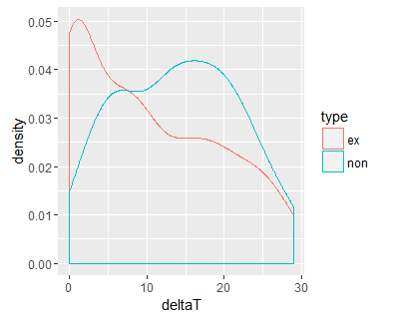

Unsure whether to use also observation where coming bird left before presence

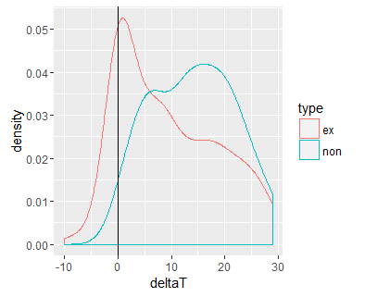

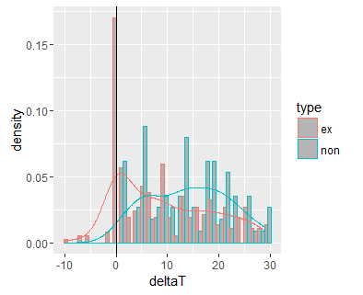

Fly off

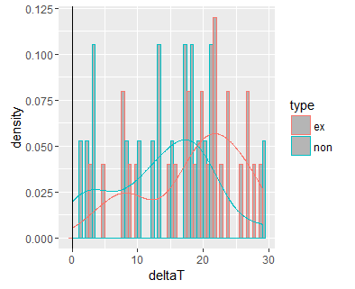

Obs 70 – left before presence, but datetime as if did not

Obs 19, 144, 151 – left before presence, but datetime as if did not

NO USED

*Duration* – We have detected the off-duty parent on the video (by sight or sound) 0.5 min before it sat down on the nest to incubate (median, min = 6 s, max = 19 min, n = 163 exchanges from 31 nests). This time mostly corresponded with the arrival of the off-duty bird to the close vicinity of the nest (i.e. start of actual exchange; rSpearmen = 0.63; SHALL WE INCLUDE SUPPLEMENTARY FIG), which happened 24 s before exchange (median, min = 5 s, max = 9 min, n = 161 exchanges from 31 nests). After arriving to the vicinity of the nest, the off-duty parent sat down on the nest quicker when its incubating partner has left the nest before the off-duty bird was present around the nest then when incubating partner left after the off-duty bird was present – be it before or after the off-duty parent initiated the exchange - i.e. arrived to the vicinity of the nest (Figure 3, Supplementary Table 3). The exchange gap (time between the incubating parent left the nest and its off-duty partner sat down lasted 15s (median, min = 0 s, max = 4 h, n = 162 exchanges from 31 nests).

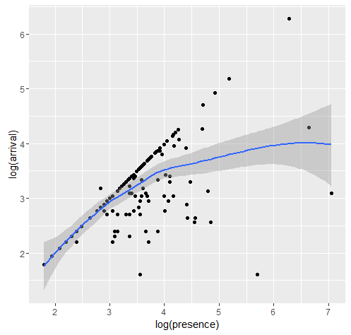

Definitions:

Presence before exchange

Exchange length

Exchange gap